**Amazon Fashion Data Analysis Report for the Quarter**

**Report Date:** 20th July 2024

**Analysis Period:** 31st march 2022 – 29th June 2022

**Prepared by:** Susmita Banerjee

**Problem Statement:**

To analyse the sales performance and customer feedback for Amazon Fashion, in order to identify key trends, areas for improvement, and opportunities for growth in the upcoming quarters.

**Goals:**

* Identify reasons for sales decline and develop strategies to sustain or increase sales.
* Reduce high return rates by aligning with customer expectations.
* Enhance customer satisfaction.
* Increase sales in lower-performing geographic areas through targeted efforts and sustain good number of sales in higher-performing geographical areas.
* Optimize inventory and marketing strategies based on category performance.

**Approach:**

* Conduct detailed data analysis to uncover trends and patterns in sales performance, customer feedback, and product returns using PowerBI.
* Gather insights on product quality and satisfaction.
* Implement recommendations in underperforming areas and categories.
* Monitor and review the impact of implemented strategies to ensure continuous improvement and growth.

**Data Overview:**

This report analyses the sales and product performance for Amazon Fashion. The data that is used to perform the analyses, contains two tables with 132K+ rows containing sales data. One contains sales related information and other one contains product related information. To get all the important data I did some basic calculations using DAX and also added some calculated columns. The key metrics reviewed include total sales, sold units, top cities by sales, order status, monthly sales’ trends, top-selling categories, average selling price, average rating, total reviews, and best-selling products.

**Key Metrics:**

* Total Sales: 89.08M
* Sold Units: 120K
* Average Selling Price: ₹780.72
* Average Rating: 4.04
* Total Reviews: 4M

All these KPI we can see as cards in the report

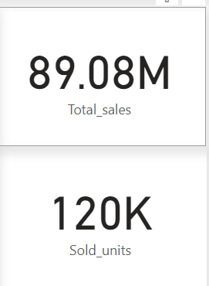 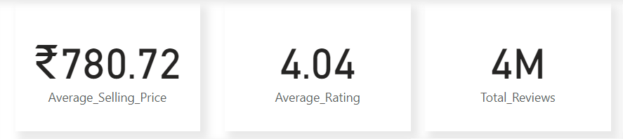

**1. Sales Performance:**

**Top Cities by Sales:**

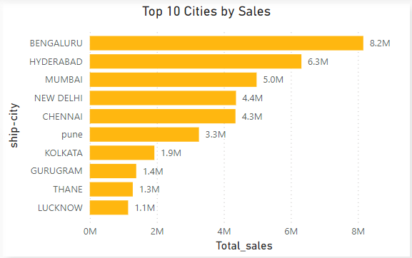

Bengaluru leads with the highest sales, followed by Hyderabad and Mumbai.

**Sales Trends by Month:**

* **March:** Sales began moderately.
* **April:** Peak sales of 34M, the highest for the quarter.
* **May:** Sales slightly declined to 29M.
* **June:** Further declining to 26M.

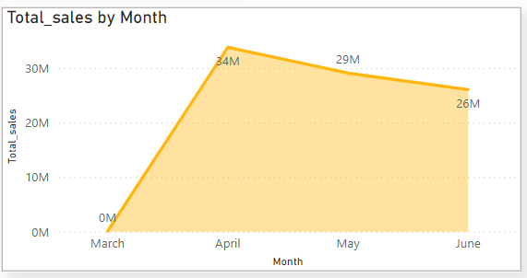

**Order Status:**

The order statuses tracked include Cancelled, Pending, Shipped, Shipped - Damaged, Shipped - Delivered to Buyer, Shipped - Lost in Transit, Shipped - Picked Up, Shipped - Rejected by Buyer, and Shipped - Returned to Seller. Using the slicer in the report, the exact number or amount of each type can be checked for any specific information.

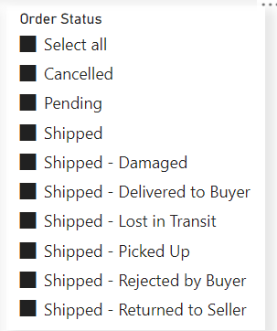

**Top Selling Categories:**

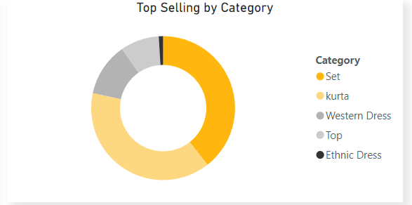

Sets and kurtas are the top-selling categories, indicating strong customer preference.

**2. Product Performance:**

**Top Rated Categories:**

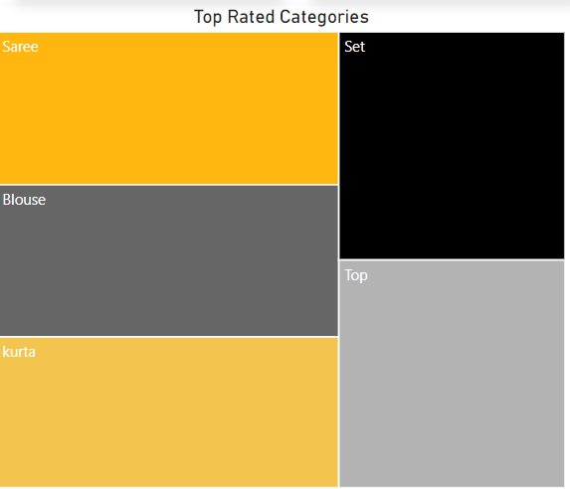

Sets and sarees receive the highest ratings, reflecting customer satisfaction.

**Most Returned Product:**

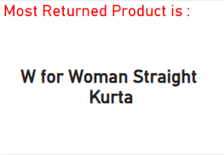

This indicates potential issues with this product, such as quality or fit, leading to higher return rates.

**Best Selling Products:**

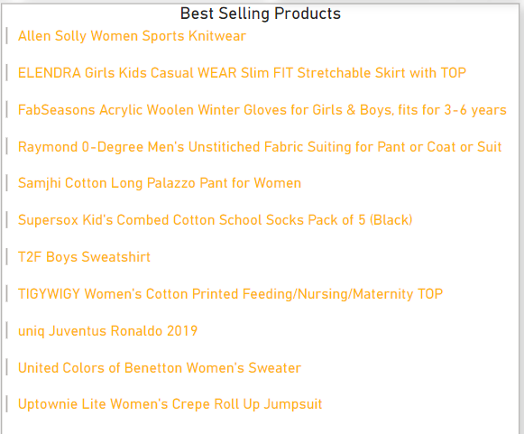

These products are the best sellers, indicating high demand.

**Conclusion:**

The quarter has shown strong sales performance, with the highest sales in April. Bengaluru is the leading city for sales, followed by Hyderabad and Mumbai. Sets and kurtas are the top-selling categories, with favourable customer ratings. However, when we dive deep into particular categories with the help of the main slicer, we can point out the areas for improvement.

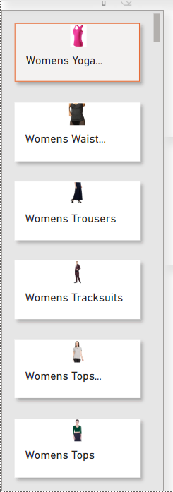

**Recommendations:**

* **Focus on Top Cities:** Increase marketing efforts and optimize logistics in top-performing cities to further boost sales.
* **Analyse Sales Trends:** By investigating the reasons for the decline in sales from April to June strategies to sustain peak sales’ levels can be implemented. Planning some sale/offers for customers during the months with less demand (months when there are not many cultural festivals/celebrations like June) can be beneficial.
* **Enhance Product Listings:** Focus on improving the visibility and attractiveness of high-rated and best-selling products to drive more sales.

Implementing these recommendations can help Amazon Fashion sustain and enhance its sales performance in future quarters.